****

**BİLECİK**

**GENÇLİK VE SPOR**

**İL MÜDÜRLÜĞÜ**

**BİLECİK KONAKLAMA LİSTESİ**

**(BGSİM Spor Hizmetleri Okul Sporları Birimi tarafından 28.02.2024 tarihinde oluşturulmuştur.)**

|  |  |  |
| --- | --- | --- |
| **Adres** | **:** | **Ertuğrulgazi Mahallesi Stadyum Sokak No:33/A BİLECİK** |
| **Telefon** | **:** | **(0228)212 5763 - (0228)212 5765** |
| **Özel Kalem** | **:** | **(0228)212 3813** |
| **Faksa** | **:** | **(0228)212 5764** |
| **E-Posta** | **:** | [**bilecik@gsb.gov.tr**](mailto:bilecik@gsb.gov.tr) |
| **Web Adresi** | **:** | [**http://bilecik.gsb.gov.tr/**](http://bilecik.gsb.gov.tr/) |

**Harita 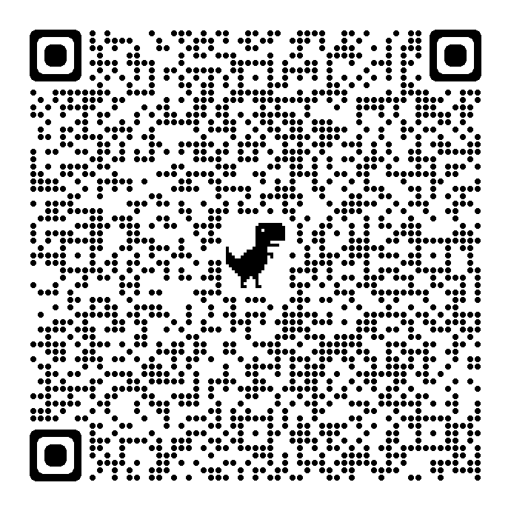**

|  |
| --- |
|  |
| |  |  |  |  |  |  |  |  |  |  |  |  |  |  |  |  |  |  |  |  |  |  |  |  |  |  |  |  |  |  |  |  |  |  |  |  |  |  |  |  |  |  |  |  |  |  |  |  |  |  |  |  |  |  |  |  |  |  |  |  |  |  |  |  |  |  |  |  |  |  |  |  |  |  |  |  |  |  |  |  |  |  |  |  |  |  |  |  |  |  |  |  |  |  |  |  |  |  |  |  |  |  |  |  |  |  |  |  |  |  |  |  |  |  |  |  |  |  |  |  |  |  |  |  |  |  |  |  |  |  |  |  |  |  |  |  |  |  |  |  |  |  |  |  |  |  |  |  |  |  |  |  |  |  |  |  |  |  |  |  |  |  |  |  |  |  |  |  |  | | --- | --- | --- | --- | --- | --- | --- | --- | --- | --- | --- | --- | --- | --- | --- | --- | --- | --- | --- | --- | --- | --- | --- | --- | --- | --- | --- | --- | --- | --- | --- | --- | --- | --- | --- | --- | --- | --- | --- | --- | --- | --- | --- | --- | --- | --- | --- | --- | --- | --- | --- | --- | --- | --- | --- | --- | --- | --- | --- | --- | --- | --- | --- | --- | --- | --- | --- | --- | --- | --- | --- | --- | --- | --- | --- | --- | --- | --- | --- | --- | --- | --- | --- | --- | --- | --- | --- | --- | --- | --- | --- | --- | --- | --- | --- | --- | --- | --- | --- | --- | --- | --- | --- | --- | --- | --- | --- | --- | --- | --- | --- | --- | --- | --- | --- | --- | --- | --- | --- | --- | --- | --- | --- | --- | --- | --- | --- | --- | --- | --- | --- | --- | --- | --- | --- | --- | --- | --- | --- | --- | --- | --- | --- | --- | --- | --- | --- | --- | --- | --- | --- | --- | --- | --- | --- | --- | --- | --- | --- | --- | --- | --- | --- | --- | --- | --- | --- | --- | --- | | |  |  |  |  | | --- | --- | --- | --- | | **TESİS**  C:\Users\caglar.cam\Desktop\indir (1).jfif | **YERLEŞİM**  C:\Users\caglar.cam\Desktop\images.png | **İLETİŞİM**  C:\Users\caglar.cam\Desktop\indir.jfif | **HARİTA**  ***Tarat* 🡪 *Tümünü Seç*  🡪 *Ara***  C:\Users\caglar.cam\Desktop\images.jfif | | **ATABEY PANSİYON** | **OSMANELİ** | **0 533 312 95 17**  **0 228 461 42 26** | C:\Users\caglar.cam\Downloads\qrcode_www.google.com (2).png | | **AYYILDIZ OTEL** | **SÖĞÜT** | **0 533 312 97 11**  **0 228 361 63 60** | C:\Users\caglar.cam\Downloads\qrcode_www.google.com (4).png | | **BAKİ PANSİYON** | **MERKEZ** | **0 507 292 35 29**  **0 228 212 39 29** | C:\Users\caglar.cam\Downloads\qrcode_www.google.com (5).png | | **BY ASIM AZAPOĞLU BUTİK OTEL** | **OSMANELİ** | **0 532 294 05 48**  **0 552 362 29 27**  **0 544 591 60 37** | C:\Users\caglar.cam\Downloads\qrcode_www.google.com (7).png | | **BİZİM APART** | **PAZARYERİ** | **0 542 424 92 26**  **0 539 498 77 33**  **0 542 455 41 11** | C:\Users\caglar.cam\Downloads\qrcode_www.google.com (8).png | | **CAN APART VE PANSİYON** | **OSMANELİ** | **0 533 352 24 24** | C:\Users\caglar.cam\Downloads\qrcode_www.google.com (9).png | | **DEMİRER APART** | **PAZARYERİ** | **0 507 947 96 45** | C:\Users\caglar.cam\Downloads\qrcode_www.google.com (10).png | | **ESEN PALAS OTELİ** | **OSMANELİ** | **0 532 793 42 68**  **0 228 461 42 09** | C:\Users\caglar.cam\Downloads\qrcode_www.google.com (11).png | | **FİDAN PANSİYON** | **MERKEZ** | **0 228 212 42 11**  **0 545 428 22 91** | C:\Users\caglar.cam\Downloads\qrcode_www.google.com (12).png | | **GRAND HOTEL BAŞARAN** | **MERKEZ** | **0 228 212 39 21** | C:\Users\caglar.cam\Downloads\qrcode_www.google.com (13).png | | **GRAND HOTEL BELEKOMA** | **MERKEZ** | **0 228 212 72 50** | C:\Users\caglar.cam\Downloads\qrcode_www.google.com (14).png | | **GRAND KENT OTEL** | **MERKEZ** | **0 544 411 11 01**  **0 228 212 78 88** | C:\Users\caglar.cam\Downloads\qrcode_www.google.com (15).png | | **GRAND ÇALI OTEL** | **BOZÜYÜK** | **0 537 045 96 11**  **0 228 314 89 30** | C:\Users\caglar.cam\Downloads\qrcode_www.google.com (16).png | | **HEYBETLİ PANSİYON** | **SÖĞÜT** | **0 228 361 24 00**  **0 532 245 14 11** | C:\Users\caglar.cam\Downloads\qrcode_www.google.com (19).png | | **KAPTANLAR PANSİYON** | **OSMANELİ** | **0 544 479 73 57**  **0 228 461 25 65**  **0 543 782 19 29** | C:\Users\caglar.cam\Downloads\qrcode_www.google.com (22).png | | **KAÇAR BUSİNESS HOTEL** | **BOZÜYÜK** | **0 228 315 55 66**  **0 530 918 55 53** | C:\Users\caglar.cam\Downloads\qrcode_www.google.com (23).png | | **KELEMCİOĞLU BUTİK OTEL** | **OSMANELİ** | **0 542 311 16 97** | C:\Users\caglar.cam\Downloads\qrcode_www.google.com (24).png | | **KESKİN APART** | **SÖĞÜT** | **0 535 463 79 19** | C:\Users\caglar.cam\Downloads\qrcode_www.google.com (25).png | | **KIZ KULESİ APART** | **MERKEZ** | **0 507 765 01 79**  **0 228 212 43 44**  **0 505 746 09 56** | C:\Users\caglar.cam\Downloads\qrcode_www.google.com (26).png | | **KRAL PANSİYON** | **OSMANELİ** | **0 553 685 10 32** | C:\Users\caglar.cam\Downloads\qrcode_www.google.com (27).png | | **NEW POINT HOTEL** | **MERKEZ** | **0 552 508 60 11**  **0 228 202 07 77** | C:\Users\caglar.cam\Downloads\qrcode_www.google.com (28).png | | **OSMANELİ OTEL** | **OSMANELİ** | **0 533 252 33 77** | C:\Users\caglar.cam\Downloads\qrcode_www.google.com (29).png | | **OSMANELİ PANSİYON** | **OSMANELİ** | **0 551 711 26 11** | C:\Users\caglar.cam\Downloads\qrcode_www.google.com (30).png | | **OTEL AKTAŞLAR** | **PAZARYERİ** | **0 532 600 40 79**  **0 228 381 23 53** | C:\Users\caglar.cam\Downloads\qrcode_www.google.com (33).png | | **OTEL ERONUR** | **MERKEZ** | **0 228 212 05 55** | C:\Users\caglar.cam\Downloads\qrcode_www.google.com (34).png | | **TAŞKIN OTEL** | **BOZÜYÜK** | **0 228 314 57 10**  **0 228 314 57 11**  **0 228 314 57 12** | C:\Users\caglar.cam\Downloads\qrcode_www.google.com (38).png | | **UNCU OTEL** | **BOZÜYÜK** | **0 228 315 23 16** | C:\Users\caglar.cam\Downloads\qrcode_www.google.com (39).png | | **UĞURCAN PANSİYON** | **MERKEZ** | **0 542 623 11 18**  **0 228 212 73 14** | C:\Users\caglar.cam\Downloads\qrcode_www.google.com (40).png | | **ZİRVEM PANSİYON** | **MERKEZ** | **0 541 830 16 41** | C:\Users\caglar.cam\Downloads\qrcode_www.google.com (41).png | | **ÇALI OTEL** | **BOZÜYÜK** | **0 228 313 03 00** | C:\Users\caglar.cam\Downloads\qrcode_www.google.com (42).png | | **ÖMÜR PANSİYON** | **OSMANELİ** | **0 541 343 54 11**  **0 544 443 54 11** | C:\Users\caglar.cam\Downloads\qrcode_www.google.com (43).png | | **ŞAHİN KIZ APART** | **MERKEZ** | **0 545 411 76 60** | C:\Users\caglar.cam\Downloads\qrcode_www.google.com (45).png | | **ŞAHİN OTEL** | **BOZÜYÜK** | **0 228 315 26 90** | C:\Users\caglar.cam\Downloads\qrcode_www.google.com (46).png | | **BOZÜYÜK ÖĞRETMENEVİ** | **BOZÜYÜK** | **0 228 314 00 60** | C:\Users\caglar.cam\Downloads\qrcode_www.google.com (47).png | | **GÖLPAZARI ÖĞRETMENEVİ** | **GÖLPAZARI** | **0 505 536 36 21**  **0 228 411 36 21** | C:\Users\caglar.cam\Downloads\qrcode_www.google.com (48).png | | **İNHİSAR ÖĞRETMENEVİ** | **İNHİSAR** | **0 554 403 04 46** | C:\Users\caglar.cam\Downloads\qrcode_inhisarogretmenevi.meb.k12.tr.png | | **BİLECİK ÖĞRETMENEVİ** | **MERKEZ** | **0 228 212 50 51** | C:\Users\caglar.cam\Downloads\qrcode_www.google.com (49).png | | **PAZARYERİ ÖĞRETMENEVİ** | **PAZARYERİ** | **0 228 381 24 11** | C:\Users\caglar.cam\Downloads\qrcode_www.google.com (50).png | | **YENİPAZAR ÖĞRETMENEVİ** | **YENİPAZAR** | **0 228 431 22 72** | C:\Users\caglar.cam\Downloads\qrcode_www.google.com (51).png | | **BİLECİK POLİSEVİ** | **MERKEZ** | **0 228 212 80 53** | C:\Users\caglar.cam\Downloads\qrcode_www.google.com (52).png | | **BİLECİK ŞEYH EDEBALİ ÜNİVERSİTESİ PELİTÖZÜ GÖLPARK MİSAFİRHANESİ** | **MERKEZ** | **0 228 214 19 19** | C:\Users\caglar.cam\Downloads\qrcode_www.google.com (58).png | | |  | | |

BİLECİK’E HOŞGELDİNİZ